Plant Structures Assignment

Go here: http://www.nhptv.org/natureworks/nwep14c.htm
Read the article.

1. Discuss the body parts of a typical moss.

2. Comparison of Body Parts of Non-Vascular and Vascular Plants
Fill in the table. (Your textbook will give you additional information.)

 | Non-Vascular Plants | Vascular Plants
Roots or rhizoids present?
True leaves present?
True stems present?
Xylem present?
Phloem present?
Stomata present?

3. Comparison of Xylem and Phloem.

 | Xylem | Phloem
Cell types present?
Lignin in cell wall?
Alive or dead at maturity?
Substances transported?

4. Match the function to the leaf structures. Note: a structure may have more than
one function.

a. allows carbon dioxide to reach the photosynthetic cells
b. helps to control water loss
c. maximizes external surface area of the blade for light interception
d. maximizes internal surface area of the leaf for light interception
e. photosynthesis
f. transportation

_______ thin flat surface of blade

_______ cuticle

_______ palisade cells of mesophyll

_______ spongy cells of mesophyll

_______ air spaces

_______ veins

_______ stomata

_______ guard cells

5. Label the following diagram of a vascular bundle from a dicot stem.

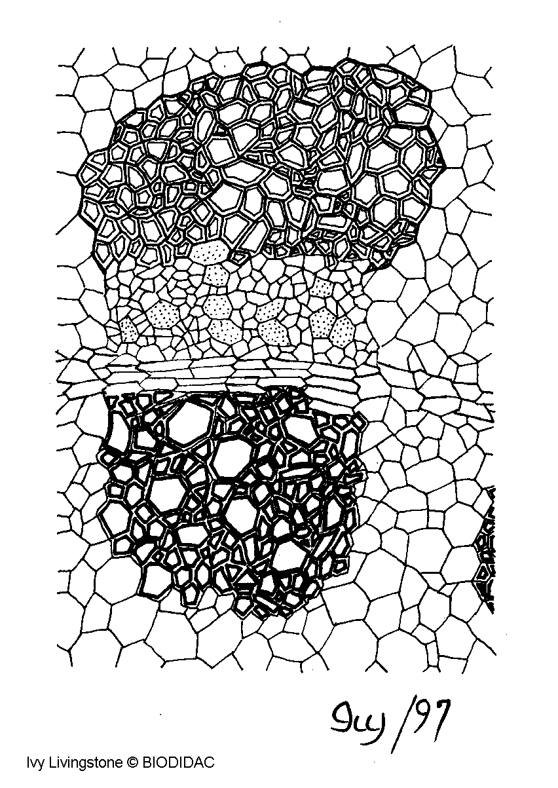
1
2

3

1. ___________________________

2. ___________________________

3. ___________________________

6. Label the following diagram of a root tip.

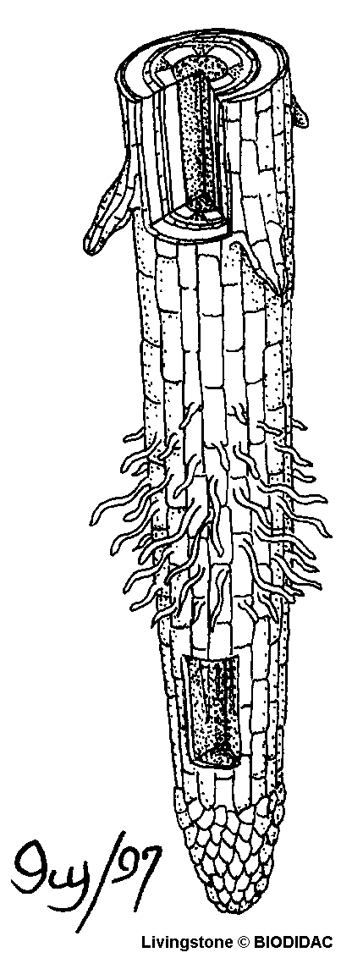
Lateral root
1
2
3
4

1. ___________________________

2. ___________________________

3. ___________________________

4. ___________________________
7. Label the following cross-section of a dicot leaf:
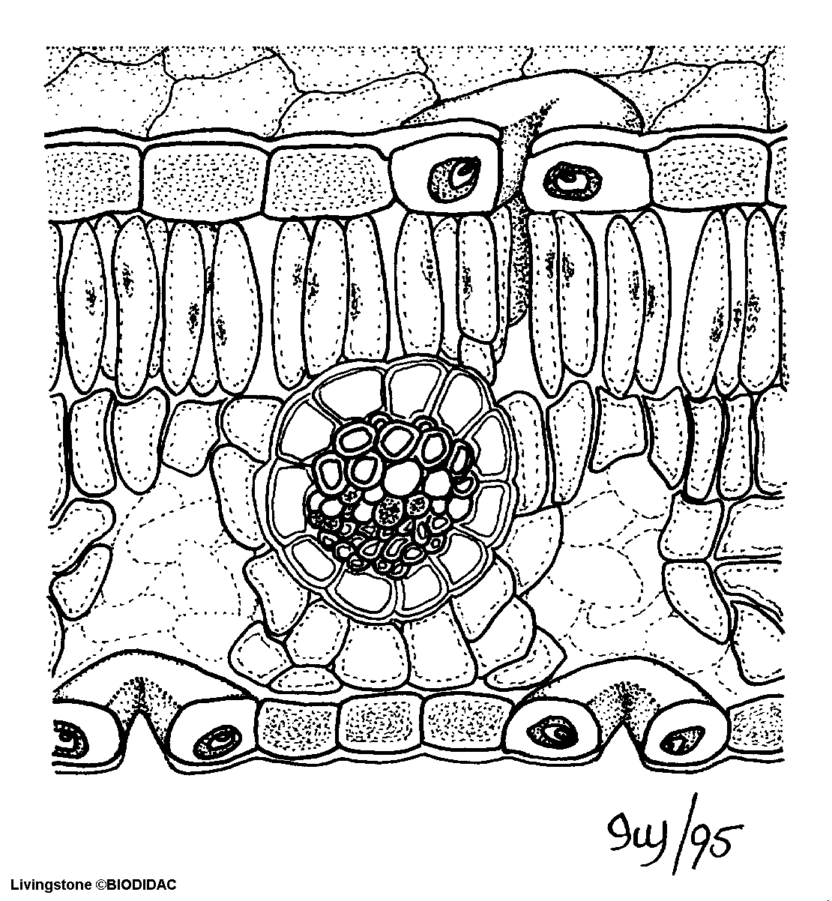
6
1
2
3
4
5
7
8
9
10

1. ___________________________

2. ___________________________

3. ___________________________

4. ___________________________

5. ___________________________

6. ___________________________

7. ___________________________

8. ___________________________ (cell)

9. ___________________________

10. ___________________________
Further Explorations

Root Systems
Go here: http://plantphys.info/plants_human/roots/rootlec.shtml
Read the article.

1. What are the advantages and disadvantages of a tap root system?
2. What are the advantages and disadvantages of a fibrous root system?
3. Which root system would be best in a forest? In a prairie?
4. What are the two (root) problems that tropical trees have to overcome? How are
tropical trees adapted to solve these conflicting problems?
5. What is a prop root? What are prop roots used for?
6. What problem do all mangroves that live in muddy swamps and marshes
(including the Black Mangrove used as an example) have to overcome? What
adaptation is used and how does it work?

